**TITLE OF PAPER – PLEASE INSERT THE TITLE OF YOUR PAPER (max. 2 rows – abstracts with longer titles will be returned to authors!)**

**Name SURNAME1, Name SURNAME2, Name SURNAME3\*** **(presenting author),**

**Name SURNAME1, Name SURNAME4**

*1Affiliation 1, full address*

*2Affiliation 2, full address*

*3Affiliation 3, full address*

*4Affiliation 4, full address*

*(please use the same identification number for authors with the same affiliation)*

*\*Corresponding author: (e-mail address)*

***Keywords: please provide up to five keywords separated by semicolon (max. 1 row).***

**Introduction:** In theheader of the document please select the Section from the *Section drop-down menu* and the form of presentation (*Oral communication* – **O** / *Poster presentation* – **P**) from the *Presentation drop-down menu.* Please savethe document as **Surname_PRIOCHEM.docx**

A concise and factual abstract is required. Please **do not** exceed one page. Abstracts exceeding one page **will be returned to authors.** The abstract should state briefly the purpose of the research, the principal results and major conclusions. The *Introduction* should clearly present objectives of the work and provide an adequate background, avoiding a detailed literature survey. **Please do not change the given formatting. All the text in red font shall be removed.**

**Materials and methods:** Thematerials and methods used for the study should briefly be presented here. Avoid extensively presenting well-known methods.

**Results:** Please provide here the principal results. Here can also be inserted figures (max. 2 figures); please use the figure template bellow (max. 3.5 cm×7cm). Do not use tables.

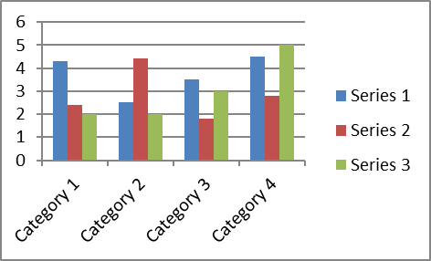

Figure 1. Caption of figure 1

**Conclusions:** Please present the major conclusions of the study.

***Acknowledgements:*** *List funding sources in compliance to funder's requirements.*

**References:** Reference citations in the text should be identified by numbers in square brackets.Please provide a list of up to five references. The entries in the list should be numbered consecutively, using the following style:

1. Smith JJ. *The world of science*. Am J Sci. **1999**, 36:234–5 (*Journal article)*.
2. Blenkinsopp A, Paxton P. *Symptoms in the pharmacy: a guide to the management of common illness*. 3rd ed. Oxford: Blackwell Science; **1998** (*Book*).
3. Wyllie AH, Kerr JFR. *Cell death: the significance of apoptosis*. In: Bourne GH, Danielli JF, Jeon KW, editors. *International review of cytology*. London: Academic; **1980**. pp. 251–306 (*Book chapter*).
4. Doe J. *Title of subordinate document*. In: *The dictionary of substances and their effects*. Royal Society of Chemistry. **1999**. http://www.rsc.org/dose/title. Accessed 15 Jan 1999 (*On-line resource*).