**TITLE OF PAPER - PLEASE INSERT THE TITLE OF YOUR PAPER**

**(max. 2 rows)**

**Name SURNAME 1, Name SURNAME 2, Name SURNAME 3*,**

**Name SURNAME 1, Name SURNAME 4**

*1INCDCP-ICECHIM Bucharest, 202 Spl. Independentei, 6th district, Romania*

*2Affiliation 2, full address*

*3Affiliation 3, full address*

*4Affiliation 4, full address*

*(please use the same identification number for authors with the same affiliation)*

*\*Corresponding author: (e-mail address)*

***Keywords: please provide up to five keywords separated by semicolon (max. 1 row)***

**Introduction**: In theheader of the document please select the Section from the *Section drop-down menu* and the form of presentation (*Oral communication* - **O** / *Poster presentation* - **P**) from the *Presentation drop-down menu.*

A concise and factual abstract is required. Please **do not** exceed one page. Abstracts exceeding one page **will be returned to authors.** The abstract should state briefly the purpose of the research, the principal results and major conclusions. The *Introduction* should clearly present objectives of the work and provide an adequate background, avoiding a detailed literature survey. **Please do not change the given formatting**. **All the text in red font shall be removed.**

**Materials and methods**: Thematerials and methods used for the study should briefly be presented here. Avoid extensively presenting well-known methods.

**Results**: Please provide here the principal results. Here can also be inserted figures (max. 2 figures); please use the figure template bellow (max. 3.5 cm×7cm). Do not use tables.

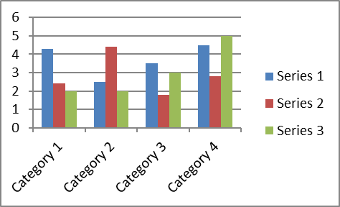

Figure 1. Caption of figure 1

**Conclusions**: Please present the major conclusions of the study.

***Acknowledgements****: List funding sources in compliance to funder's requirements.*

**References:** Reference citations in the text should be identified by numbers in square brackets.Please provide a list of up to five references. The entries in the list should be numbered consecutively, using the following style:

1. Smith JJ. The world of science. Am J Sci. 1999;36:234–5 (*Journal article)*.
2. Blenkinsopp A, Paxton P. Symptoms in the pharmacy: a guide to the management of common illness. 3rd ed. Oxford: Blackwell Science; 1998 (*Book*).
3. Wyllie AH, Kerr JFR. Cell death: the significance of apoptosis. In: Bourne GH, Danielli JF, Jeon KW, editors. International review of cytology. London: Academic; 1980. pp. 251–306 (*Book chapter*).
4. Doe J. Title of subordinate document. In: The dictionary of substances and their effects. Royal Society of Chemistry. 1999. http://www.rsc.org/dose/title. Accessed 15 Jan 1999 (*On-line resource*).