**TITLE OF PAPER - PLEASE INSERT THE TITLE OF YOUR PAPER**

**(max. 2 rows)**

**Name SURNAME 1, Name SURNAME 2, Name SURNAME 3*,**

**Name SURNAME 1, Name SURNAME 4**

*1INCDCP-ICECHIM Bucharest, 202 Spl. Independentei, 6th district, Romania*

*2Affiliation 2, full address*

*3Affiliation 3, full address*

*4Affiliation 4, full address*

*(please use the same identification number for authors with the same affiliation)*

*\*Corresponding author: (e-mail address)*

***Keywords: please provide up to five keywords separated by semicolon (max. 1 row)***

In the header of the document please insert the Section code:

- MTCH - Multifunctional materials, nanocomposites, innovative technologies and cultural heritage protection

- BBB - Bioresources, biotechnologies and biorefining.

A concise and factual abstract is essential. Please do not exceed one page. Abstracts exceeding one page will be returned to sender. The abstract should briefly state the purpose of the research, leading results and key conclusions. **Please do not change the given formatting**.

**All text that has been pre-highligted in red shall be removed.**

**Introduction**: This section should clearly present the targeted objectives of the work and provide an adequate proof of affiliation to whichever School of Thought, avoiding a detailed literature survey.

**Materials and methods**: Use this sectionto briefly advance your idea/study/investigation. Avoid extensive descriptions to classical methods and focus on chipping at the precipice of knowledge in your specialty domain.

**Results**: This section ought to feature your study’s leading results along-side inserted graphs (max. 2 graphs of 3.5 cm×7cm); you should refrain from inserting tables and elevate to other visual means of demonstration.

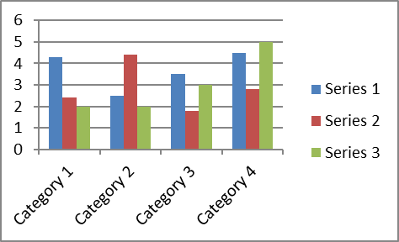

Figure 1. Caption of figure 1

**Conclusions**: This is the section to assert the theory of knowledge brought to light by means of your study.

***Acknowledgements****: List funding sources in compliance to funder's requirements.*

**References:** Reference citations in the text should be identified by numbers in square brackets - superscript.Please provide a list of up to five references. The entries in the list should be numbered consecutively, using the following style:

1. Smith JJ. The world of science. Am J Sci. 1999;36:234–5 (*Journal article)*.
2. Blenkinsopp A, Paxton P. Symptoms in the pharmacy: a guide to the management of common illness. 3rd ed. Oxford: Blackwell Science; 1998 (*Book*).
3. Wyllie AH, Kerr JFR. Cell death: the significance of apoptosis. In: Bourne GH, Danielli JF, Jeon KW, editors. International review of cytology. London: Academic; 1980. pp. 251–306 (*Book chapter*).
4. Doe J. Title of subordinate document. In: The dictionary of substances and their effects. Royal Society of Chemistry. 1999. http://www.rsc.org/dose/title. Accessed 15 Jan 1999 (*On-line resource*).